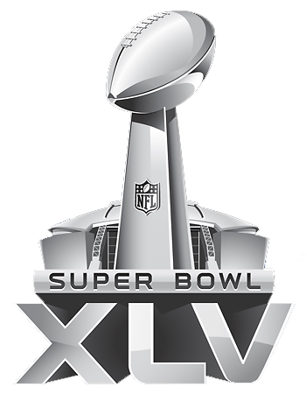
Super Bowl XLV Potluck Party
February 6th, 2011
Are you ready for some football???
Where: Bear’s Den Resort Clubhouse
Time: Game Time @ 5:30pm
Dinner @ Halftime
Come join us for some fun & games as we celebrate the 45th Super Bowl. We are asking that each member bring chips, dip, beverages, etc. Bear’s Den will be providing the hot dogs and buns as well as the condiments.
For questions or to sign up for a pot luck dish, please call The Kountry Store at (918) 786-6196.
Hope to see you there!!!
*All events subject to change

